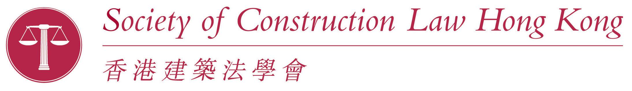Talk after the AGM

Presenting a case in Mediation - a QC's perspective
Wednesday, 14 June 2017
Following the SCLHK AGM which will be held at the Hong Kong Club, 3A Chater Road, Central, Hong Kong, Philip Boulding QC will give a presentation based upon his experiences of acting as a mediator and in preparing for and appearing in mediations as an advocate. Philip will explain from his perspective how to present a client's case to best effect.

About the speaker

Philip Boulding QC was educated at the Cambridgeshire High School for Boys, Cambridge and thereafter Downing College, Cambridge, where he involved himself in many sports and represented Cambridge University twice against Oxford University at Twickenham (both winning ‘Blues’) as well as representing England at U23 level.

Philip also was awarded a B.A. (Law) (with 1st Class Honours), an M.A. and a LL.M and was elected to the title of Scholar of Downing College, as well as being a Pilley Scholar and Senior Harris Scholar of the College and the Rebecca Flowers Squire Scholar of Cambridge University.

Philip has been a member of Keating Chambers since 1980, specialises in the fields of construction, engineering, technology law and related professional negligence work and has a very substantial practice in Asia and, more recently, Australia. In Hong Kong he is perhaps best known for arguing (successfully) that it was ‘physically impossible’ to construct the Tsing Ma Bridge!

Philip took ‘silk’ in 1996 and is a Bencher of Gray’s Inn, sits regularly as an adjudicator, mediator and arbitrator, is a contributor to Keating on Construction Contracts, is a consultant editor of the Construction Law Reports and a regular speaker at conferences and seminars throughout the world.

Venue: | The Hong Kong Club, 1 Jackson Road, Central, Hong Kong
Date / Time: | Wednesday, 14 June 2017; 6.00 pm for 6.30 pm
Cost: | No charge
Please register by returning the registration application slip below and your cheque, to Membership Administration, Society of Construction Law Hong Kong, 38/F, Two Exchange Square, Central, Hong Kong. For enquiries please contact Ms Raj Brar on +852 2525 2381, fax +852 2524 2171.

REGISTRATION FORM OVERLEAF

Talk after the AGM

Presenting a case in Mediation - a QC's perspective

Wednesday, 14 June 2017

REGISTRATION FORM

Name: ________________________________ I am a member of the SCLHK.

Please note that there is no charge for this event.

Please reserve one seat for myself and _____ seats for guests.

Phone No. (Day time): ____________________________
Fax________________ E-mail _______________________________________

Events by other organisations can be found on the SCLHK website at: http://www.scl.hk/meetings.php

